**Linux commands**

Ls –l

Touch file name

Find --🡪search file or directory

How to find the empty files in the current directory?

Find . –type f

How to find the empty files in the root directory?

Find / –type f –empty

How to find the empty files in the user home directory?

Find ~ –type f –empty

How to find the empty directory in the current directory?

Find ~ –type f –empty

Base permissions for directory is ?

0777

Rwx----🡪read wrirte execute

User others permission

| |

Rwx rwx rwx

|

Group permissions

Umask value for the normal user is 0002

$umask

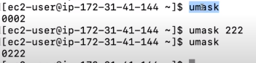

Bsae permid